**The endocrine system**

* **The hypothalamus, pituitary gland, thyroid, parathyroid, pancreas, thymus, gonads, pineal and adrenal glands, that are endocrine glands found in the human body.**

-The endocrine system regulates the activity of cells by sending out hormones, they are chemical messengers.

- The endocrine system maintains a constant environment inside of the body called homeostasis.

-When the body experiences a change it is a stimulus.

Endocrine glands (Ductless glands)

-Endocrine glands release hormones to the extra-cellular fluid that surround the cells of the gland.

-The secretions pass through the capillaries

-They get to the bloodstream to be transported to the target organs.

Exocrine glands

-Exocrine glands secrete substances out to the epithelial surface (external surface) via a duct.

-Examples are sweat glands, oil glands, salivary glands, mucous glands etc.

* **Explain how hormones secreted from the hypothalamus, pituitary, thyroid, parathyroid, thymus, gonads, pineal, pancreas and adrenal glands are involved in homeostasis by affecting specific target organs.**

Hypothalamus

-It is located in the base of the brain

-regulates body temperature, water balance and heart rate, sleep patterns, eating patterns.

-A lot of functions of the hypothalamus happen in the pituitary gland A.K.A ‘Master gland’

-The hypothalamus produces releasing and inhibiting factors for the anterior lobe and it produces hormones ADH and oxytocin for the posterior lobe.

-The posterior lobe is connected by nerve fibers that run through infundibulum.

-The anterior lobe is connected by complex blood vessels in the infundibulum.

**The production of hormones in the hypothalamus**

There are two sets of nerve cells in the hypothalamus that produce hormones. One set sends the hormones they produce down through the pituitary stalk to the posterior lobe. The other set produces releasing and inhibiting factors that get sent down the complex blood vessels in the infundibulum to the anterior lobe where they are then stored and released when needed.

Anterior lobe

The anterior lobe secretes hormones that control many of the body’s activities.

Hormones start to release from the anterior lobe once ‘releasing factors’ have been secreted from the hypothalamus. The hypothalamus also releases ‘inhibiting factors’ to slow secretion down.

Hormones releases by the anterior lobe include:

-**Gonadotropins (FSH, LH)**; Hormones that affect the sexual organs such as the testes and ovaries.

-**Follicle-stimulating hormone (FSH)** in the ovary to stimulate the growth of eggs

-**Growth hormone (GH)** which stimulates body growth and maintains size of organs.

-**Prolactin (PRL)** which works with other hormones to help secret milk in females.

-**Thyrotropin or (TSH)** which stimulates production or release of thyroid hormones

**-Adrenocorticotrophic** **(ACTH)** hormone controls the production and release of hormones from the adrenal cortex

Posterior lobe

The Oxytocin and ADH hormones are produced by a special set nerve cells in the hypothalamus that travel through long nerve extensions in the infundibulum to the posterior lobe where they are then stored and then released into the bloodstream.

Hormones released by the posterior lobe are:

-**Oxytocin** which stimulates the contraction of muscles in the uterus and also the cells of mammary glands to release milk.

-**Antidiuretic** (**Vasopressin**) hormone allows water reabsorption into the collecting duct so more fluid is available for the body. It also constricts small arteries. Hence, that’s why it’s also called ***vasopressin***. Anti-diuretic literally means ‘anti-peeing’. So urination is decreased. It’s usually released in hot environments or when dehydrated. It also decreases the permeability of the distal convoluted tubule so less water becomes enters the tubule to become filtrate.

Pineal gland

It is located deep in the brain, on top of the mouth. Not much is known by scientists about it. It is known to release melatonin in dark environments such as when you are getting ready to go to bed.

Thyroid

-It’s located in the neck

-Two lobes that lay either side of neck connected by tissue

-It uses iodine and amino acid to make two hormones, T3 (Triiodithyronine) and T4 (thyroxine)

- T3 and T4 are released in response to Thyroid-Stimulating hormone from anterior lobe.

-Controls reactions in which complex molecules are broken down to release energy and reactions where simple molecules are synthesized into complex ones.

-Releases energy in form of heat so it maintains body temperature.

-T3 and T4 regulate cellular respiration/the heart rate/digestion speed.

Parathyroid

-There are usually 4 parathyroid glands.

-They are found at the back surface of the thyroid gland.

-They control phosphate (P) and calcium (Ca) levels in the blood.

-Effects bones, intestines and kidneys

Thymus

-It’s located above chest below the thyroid gland.

-Releases thymosins which mature T-lymphocytes; disease fighting cells.

-Shrinks after puberty and as you age.

Gonads

-They are testes and ovaries

-Androgens are male sex hormones produced by testes, it helps develop secondary male characteristics.

-Oestrogen is a female sex hormone produced by the ovaries, it regulates the menstrual cycle and sexual characteristics.

Adrenal glands

-There are 2 adrenal glands and 1 is located above each kidney.

- Each adrenal gland has an adrenal medulla and adrenal cortex

Adrenal medulla

-Inner portion of adrenal gland

-Produces adrenaline or epinephrine which increases heart rate in a threatening situation in which the fight or flight response occurs.

-Produces noradrenalin which is similar to adrenaline but increases rate and force of heart rate.

Adrenal cortex

-Outer portion of adrenal gland

-Produces cortisol which with the help of other hormones helps body withstand stress, repairs damaged tissues and promotes normal metabolism

-Produces aldosterone which acts on the distal convoluted tubule to secrete potassium in the filtrate and to reabsorb chloride back to the bloodstream along with water.

Pancreas

-Lies below the stomach beside the duodenum (first part of intestine)

- It is both and endocrine and exocrine gland

-Special cells called islets-of-langerhans are the endocrine part of the pancreas

-The beta cells release insulin and the alpha cells release glucagon.

-Both help regulate levels of blood glucose

Insulin

-reduces glucose in the blood (blood sugar level)

-Promotes uptake of glucose from blood by cells of body to helps body get the energy from the food we need vya cellular respiration.

-In liver, converts glucose into glycogen and fat.

-In fat tissue, converts glucose into fat.

-In skeletal muscles, converts glucose into glycogen.

Glucagon

-opposite of insulin

-Increases blood sugar level

-In liver, breaks down glycogen into glucose

-In fat tissue, breaks down fat into glucose.

* **Discuss how hormones can be lipid-soluble and be able to cross cell membranes to bind with and activate intracellular receptors or, water-soluble and able to bond with or activate receptors on cell membranes, and require secondary messengers to affect cell functioning.**

-Cells can communicate with other cells in same tissue by secreting chemicals that diffuse through adjacent cells; these substances are called **Paracrines** A.K.A Local Hormones

-Paracrines are secreted by all cells and move through extracellular fluid.

-Hormones are released by specialized cells and are very specific. They are transported by the bloodstream to the target cell and the hormone receptors on the cell can become saturated.

**-Protein and amines** (end with ‘**in**’, ‘**ine’**) attach to receptor proteins found on the membranes of the cell

-When a hormone and a receptor combine, a secondary messenger called Cyclic AMP (cAMP) diffuses through the cell to activate a certain enzyme to cause change to the cell.

-Receptor proteins are very specific; they will only bind with a particular specific protein or amine molecule.

-One all receptors are bound to a molecule (saturation), there will be no more affect from the hormone no matter how much is sent out.

**-Steroid hormones** (end with ‘**ol**’, ‘**one’**, ‘**on’**, ‘**en’**)

Theyenter the cell and bind with specific receptor proteins in the cytoplasm to be transported to the nucleus with the receptor.

-The specific protein receptor could be mitochondria, or other organelles.

**Hormones can change; R-S-Q: (rate, shape, quantity)**

-Activate certain genes in the nucleus so an enzyme or protein is produced  
-Change the structure of the cell. This turns it ‘on’ or ‘off’  
-Change the rate of enzymes produced by changing the rate of transcription and translation during protein production.

**Enzyme amplification**

-A single hormone molecule can produce or activate thousands if not millions of enzymes.  
-A very small stimulus can amplify into a large response

**Hormone clearance**

If a hormone has completed its desired effect, it will be turned off. This is done by breaking down the hormone molecules, usually done in liver and kidneys

-Broken down hormones are secreted in bile and urine

**Control of hormone secretions**

-A **change to the body** is called a **stimulis**

-A feedback system is when the body produces more or less of a hormone to change the original stimulus.

-Negative feedback systems is when the response produced from the secretion of the hormone is the opposite of the response stimulis

-Feedback systems can involve the nervous system through release of **regulating factors** from brain

-These factors are ‘releasing factors’ which release hormones and ‘inhibiting factors’ which slow down the secretion of hormones.

* **hormones are developed using recombinant DNA and associated biotechnological techniques**

**Biotechnology**

-Any process based on biology that is used in medicine. It helps to;

- Identify inherent diseases.  
-Produce human proteins, hormones or vaccines.  
-Treat diseases.

**Recombinant DNA**

-The process of adding foreign DNA to a cells genome to change its genetic material. This is what’s called genetic engineering.

-This can help replace faulty genes  
-Produce more of a hormone

If an organisms genome has been changed by the insertion of genes of other organisms. It’s called a **transgenic organism**

DNA enzymes are involved in the synthesis, binding and break up of DNA.

Examples of DNA enzymes are: -**Polymerase**

**-Restriction enzymes**

**-Ligase**

**DNA polymerase**

-Makes copies of other strands of DNA in DNA replication and repair, it reads intact DNA and uses it as a template to form a new DNA. It produces copies of DNA from DNA fragments from a crime scene using ‘polymerase chain reaction’

**Restrictive enzymes**

Occur naturally and they are a defence mechanism against viral DNA in bacteria. Such as ‘EcoRI’. When a virus tries to inject its DNA and RNA into a bacterium. The bacterium releases restrictive enzymes that *slice* the DNA into small strands. A Restrictive enzyme cuts in very specific locations called recognition sites where a particular sequence of nucleotides are located. Once DNA is cut, its exposed nucleotides are called sticky ends. Some restrictive enzymes make a straight cut in which the ends are non-exposed.

**DNA Ligase**

It’s job is to join two strands of DNA together. This process is called **ligation**. The exposed ends of a DNA strand are attracted to the complimentary base pairs of another DNA molecule and then the DNA enzyme ligase joins them together by their sugar phosphate backbones.  
-If the gene is different from the DNA strand it’s being ligated to. It’s called ‘recombinant DNA’

**The recombinant DNA process**

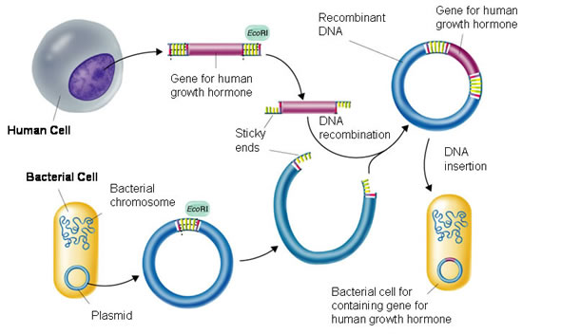

The recombinant DNA process involves 4 steps;

1. Isolate 2. Cut 3. Join 4. Reproduce.

A **vector** is used to transport a gene from one cell to another.

A circular DNA molecule found in bacterium is called a **plasmid**. It acts as a vector. The plasmid must be removed from the bacterium before used as a vector. We use **restrictive enzymes** to **isolate** genes in the DNA and then cut the DNA in specific places in the sequence called **recognition sites** to obtain the gene.

The restrictive enzyme used for the plasmid must be the exact same used for the DNA strand of the human cell so complimentary pairs can be formed between the plasmid and the gene. The cut ends of the gene and plasmid are exposed and form sticky ends. The plasmid and the gene are then attracted to their complimentary base pairs and are linked by the DNA enzyme **Ligase** by their sugar backbones.

The plasmid that contains the gene (vector) is then inserted into a bacterium cell, mammalian cell or yeast cell. This is called **transformation**. Once the gene is inserted in the cell the bacterium cell replicates and then the new cells created that contain the gene are called **transgenic.**

**Applications of recombinant DNA technology**

-The cells that contain the inserted gene start to replicate into more cells using the instructions of the gene. This allows large quantities of pure protein to be produced such as insulin, human growth hormone, follicle stimulating hormone etc.

-A patient has type I diabetes, which means they have a weakened production of insulin and require regular injections of insulin to maintain sugar levels. As a doctor, you can provide them with hope that the process of recombinant DNA (genetic engineering) will help him with his insulin injections.

**The central and peripheral nervous system**

* **The parts of the central nervous system, including the brain (cerebrum, cerebellum, medulla oblongata, hypothalamus, Pons, the midbrain, thalamus, hypothalamus, brain stem and corpus callosum) and spinal cord, have specific roles in the coordination of body function and are protected by the meninges and cerebrospinal fluid.**

The brain and spinal cord make up the central nervous system and they are made out of neurons. The CNS is where messages are processed and sent out from. The Peripheral nervous system is the nerves that connect the central nervous system with the muscles, organs and glands.

The brain and spinal cord are very delicate and vital to the body so they are heavily protected. They are protected by 3 structures; Bone, meninges and cerebrospinal fluid.

**Bone**

The outermost protective area of the CNS is the bone. The brain is protected by the cranium bone which is the part of the skull that protects the brain. The spinal cord runs from the foramen magnum from the skull and through the vertebral canal which is a hole in the vertebrae.

**Meninges**

Underneath the bone protective layer are 3 layers of connective tissue that form membranes. These membranes are called meninges. There is an outer layer (dura mater), middle layer (arachnoid membrane) and an inner layer (Pia matter). The outer layer is tough and fibrous, the middle layer is a loose mesh of fibres and the inner layer is delicate, contains many blood vessels and sticks closely to the surface of the brain and the spinal cord.

**Cerebrospinal fluid (CSF)**

The cerebrospinal fluid is a clear, watery fluid that is formed in the choroid plexus in the ventricles of the brain. The CSF is made up of few cells and contains proteins, urea, salts and glucose. It is found between the middle and inner layers of the meninges layers. The CSF circulates around and through the CNS and eventually re enters the blood capillaries. It has 3 functions. It provides **protection,** **support** and **transport**. (PST)

It **protects** the spinal cord by acting as a shock absorber that lessens any blows to the brain and spinal cord. It **supports** the brain and spinal cord by providing nutrients and allows the brain to be suspended and float in the cranium. It helps **transport**; during its circulation through and around the CNS it provides nutrients to the cells of the brain and spinal cord and removes their waste.

**Cerebrum**

It is the biggest part of the brain and it outer layer of grey matter called the cerebral cortex. It has a middle layer of white matter and deep inside of the brain in each hemisphere there it has an area of grey matter called the **basal ganglia** which contains cell bodies and is involved in coordination of movement control of skeletal muscles and the eyes.

The cerebrum is concerned with the thinking, learning, memorizing, intelligence, and reasoning, sense of responsibility, the perception of senses and the contraction of voluntary muscles.

The cerebral cortex consists of folds called **convolutions** A.K.A **Gyri** that allow the surface area of the brain to increase greatly. Because of this, 70% of the neurons in the brain are in the cerebral cortex.

The shallow down folds are called **sulci** and the deep down folds are called **fissures**. The deepest fissure in the brain is called the **longitudinal fissure**. It separates the cerebrum in two pieces, a left and right cerebral hemisphere. The right hemisphere is concerned with the creative and artistic abilities and controls the left side of the body and the left hemisphere is concerned with the logical and academic processes and controls the right side of the body.

Underneath the cerebrum and at the base of the longitudinal fissure; the two hemispheres are connected by a large bundle of myelinated transverse fibres called the **corpus callosum.** The corpus callosum allows carries impulses and allows communication between the left and right hemispheres.

The convolutions on the cerebrum vary between people but certain fissures and sulci are constant and they divide the brain into 4 different lobes; **the frontal, temporal**, **parietal** and the **occipital lobes**. Deep inside the brain there is a fifth lobe called the **insula**.

The boundaries of areas are indistinct so the functions of the brain overlap each other which mean a part of the brain can have multiple functions.

The general parts of functional area in the cerebral cortex include:

**Sensory areas** – receives and processes nerve impulses from senses

**Motor areas** – sends impulses to muscles to contract muscles

**Association areas** –It interprets information from the brain and make them useful (emotions and memory). Memories are pathways of neurons. When new memories are stored new links are made between neurons or links are changed.

The size of hemispheres is not exactly identical. For example, right handed people have a larger right frontal lobe.

In the CNS the bundles of nerve fibres are called **tracts.** There are 3 types of tracts in white matter;

1. Tracts that **connect** the cerebral cortex to **other parts of the cerebral cortex** in the same hemisphere

2. Tracts that **carry impulses** to the **right** and **left** **hemisphere**

3. Tracts that **connect** cortex to **other parts** of the **brain** and **spinal cord**.

**Cerebellum**the cerebellum is inferior to the posterior part of the cerebrum. It is the second largest part of the brain. Its surface is folded into parallel ridges. The outer part of the cerebellum is grey matter and the inner part is white matter.

The cerebellum controls **posture and balance** and the **fine coordination of voluntary muscle movement**. It receives sensory information from the inner part of the ear for posture and balance and sensory impulses from the stretch receptors in the skeletal muscles.

The cerebellum functions on a below conscious level. It doesn’t produce any impulses. We would have a jerky, uncontrolled movement without the cerebellum.

**Hypothalamus**The hypothalamus is found in the middle of the brain. Its purpose is to maintain a constant environment within the body. This is called homeostasis.

It’s job is to regulate; water and food intake, body temperature, sleeping and waking patterns, emotional responses such as fear, pleasure, anger, aggression and contentment, the secretion of hormones, the autonomic nervous system (secretion of digestive juices, diameter of eye pupils, heart rate, movement of alimentary canal, blood pressure).

**Medulla oblongata**

-It is a continuation of the spinal cord and found just above where the spinal cord enters the skull. It has 3 centers; the cardiac centre, the respiratory centre and the vasomotor centre.

The cardiac centre regulates the rate and force of the heart beat.  
The respiratory centre regulated the rate and depth of breathing.  
The vasomotor centre regulates the diameter of blood vessels.

-The medulla oblongata regulates the **reflexes** of swallowing, sneezing, breathing, vomiting and coughing.  
All the centers of the medulla oblongata are regulated by higher centers in the brain such as the hypothalamus.

**Pons**-It is found anterior and superior to the medulla oblongata-The Pons acts a relay station that processes information to the cerebellum and from the cerebellum.   
-It contains the pontine centres: pnuemotaxic and apneustic centers of brain.  
-It also has cranial nerves

**Midbrain**-The midbrain sends information to other parts of the brain.   
-Allows reflexes that coordinate the movement of the eye and head.  
-It processes auditory and visual information  
-Regulates the reflexes of squinting from a bright light or turning the head when a loud noise occurs.  
-Some neurotransmitters in the midbrain release the transmitter ‘dopamine’  
 **Thalamus**-Contains neurons that allow connecting between the forebrain and the hindbrain so itonnects areas of the sensory system together (except area of smell).  
-Often called ‘The great relay station of the brain’.

**The Spinal cord**-The spinal cord extends from a large opening in the base of the skull called the foramen magnum and through a hole in the vertebrae called the vertebral canal.   
-The vertebral canal is the length of the spinal cord which is 45 cm in length. Below that level, the vertebral canal contains spinal nerve roots and meninges.  
-The spinal cord has a central canal where there are ascending and descending tracts that go up and down. The tracts are made out of bundles myelinated nerve fibers.  
-The ascending tract is made out of sensory axons that carry impulses towards the brain and the descending tracts are made out of motor axons that carry impulses to effectors such as organs, muscles, glands etc.

**Functions of the spinal cord**   
-Integrates automatic, protective reflexes   
-it carries messages from the PNS to the brain and carries messages from brain to effectors.

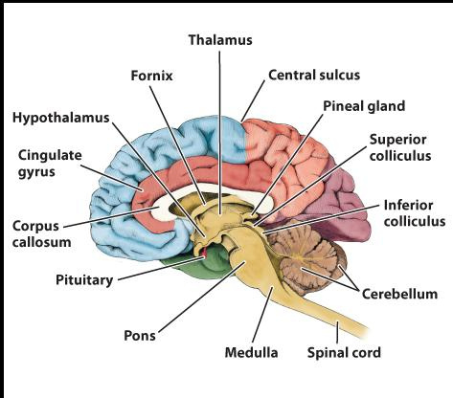

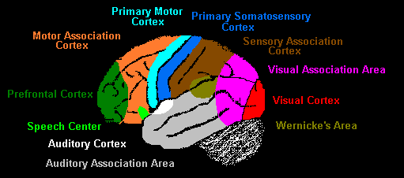

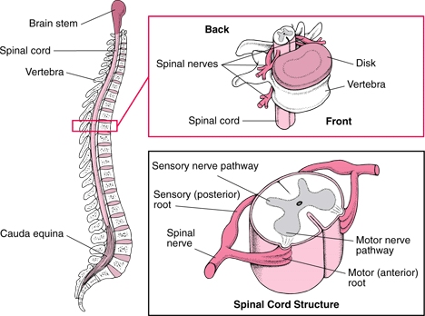

* **The reflex arc comprises of specially structures neurons, including sensory, interneuron and motor neurons, to transmit information from the receptors to the effectors to respond rapidly to stimuli.**

The central nervous system is only composed of two types of cells. **Neurons** and **Glial cells**.

**Neurons**  
-highly specialized cells of the central nervous system.   
-they are nerve cells that generate electrochemical impulses to communicate between other neurons to other parts of the body.  
-vary greatly in size and appearance depending where they are in the body.

Neurons are composed of a **cell body**, **axon** and **dendrites**.

**Cell body**; contains the nucleus suspended in cytoplasm and have organelles found in most cells such as mitochondria, ribosomes, endoplasmic reticulum, Golgi apparatus.

**Dendrites**; are short extensions of the cytoplasm of the cell body, they are highly branched and receive impulses from other neurons

**Axon**; often a single long extension of the cytoplasm of the cell body. It carries impulses away from the cell body. Usually longer than dendrites although the length varies enormously.

**Neurons can be classified by their structure;**  
**Multipolar neurons**-Single axon and multiple dendrites from cell body.  
**Bipolar neurons**-Single axon and single dendrite, dendrites can have many extensions and branches.  
**Unipolar neurons**-Single axon and cell body to the side of the axon.

**Myelin**-A white layer of fatty material.  
-It is formed by special cells that wrap around axon in PNS called Schwann cells.  
-It is formed by special cells that wrap around axon in CNS called oligodendrocytes  
-Nodes of Ranvier are microscopic gaps along the myelin sheath which speeds up the movement of nerve impulses along axon  
-The sheath is an insulator so it protects axons from damage  
-The outer most layers there is a structure called neurilemma which provides nutrients and repairs injured fibers. Schwann cells and oligodendrocytes have nuclei.

A nerve cell is a neuron; a long extension of cytoplasm of a cell body is a nerve fiber; a nerve is a bundle of nerve fibers. They are called **tracts** in the central nervous system.

**Motor (efferent) neurons**-Mostly multipolor neurons.  
-Takes nerve impulses from CNS to effectors.  
-Axon terminals attach to effectors structures such as muscles or glands  
-Dendrites form a synapse with the spinal cord  
-Is automatically or voluntarily stimulated

**Sensory (afferent) neurons**-Mostly unipolar neurons, Carries nerve impulses from the receptors in the skin to the CNS, Axon forms a synapse with the interneuron on the spinal cord, Sensory receptors are at the end of dendrites

**Interneuron (A.K.A relay, association, connector neurons)**-Links sensory and motor neurons  
-Found only in the CNS.

**Neuroglia (Glials cells)**  
-Provides neurons with nutrition, removes their wastes, protects them against infection and insulates neurons from other neurons  
They make up 40% of the central nervous system.  
Most cell bodies are in the grey matter of the brain and spinal cord.

**Reflex**certain neurons are organized to enable body to react rapidly to a situation without thinking about it. It is a fast, unlearned involuntary response that does not involve brain. We only become aware of the reflex after the reflex has been initiated. All reflexes have **4 important properties;**-A **stimulus** triggers a reflex. Reflex doesn’t come out of nowhere.  
-Reflexes are **involuntary**. There are no conscious thoughts.  
-Reflex responses are **rapid**. They involve a small number of neurons  
-A reflex is **stereo-typed**. It occurs the same way each time.  
  
Most reflexes are coordinated by the spinal cord. In reflexes. The impulse is passed to motor neurons at the same level in the cord or they can travel slightly up or slightly down the cord before being carried out by a motor neuron. When the reflex is carried out by the spinal cord alone it is known as a **spinal reflex**. The pathway of nerve impulse from a receptor to effectors is known as a **reflex arc** or a **spinal reflex arc** for a spinal reflex.

**Reflex arc**  
the pathway of a nerve impulse from a receptor to effectors is known as a reflex arc. A reflex arc is composed of 5 components.

1. A receptor reacts to a change in the internal or external environment by initiating a nerve impulse to the sensory neuron.  
2. A sensory neuron carries impulses from receptors to the CNS  
3. The impulse will travel up or down the spinal cord slightly before being transferred to a motor neuron via an interneuron. Or in some cases, the impulse will transfer to the sensory neuron at the same level on the spinal cord.  
4. The motor neuron will carry the impulse to the effector structures such as muscles, organs or glands.  
5. The effector receives the nerve impulse and carries out the appropriate response.

Impulses would occur in a fraction of a second and while it was occurring impulses would travel to the brain and only after the response has occurred the person would be aware.

Reflexes include; blinking, coughing, squinting, sneezing, constriction of pupil, vomiting, responses of the autonomic nervous system. (ANS)

**Acquired reflexes**-They are reflexes learned through constant repetition such as braking a car suddenly, balancing yourself on a bike, blocking a punch or adjusting muscles to balance a bike.

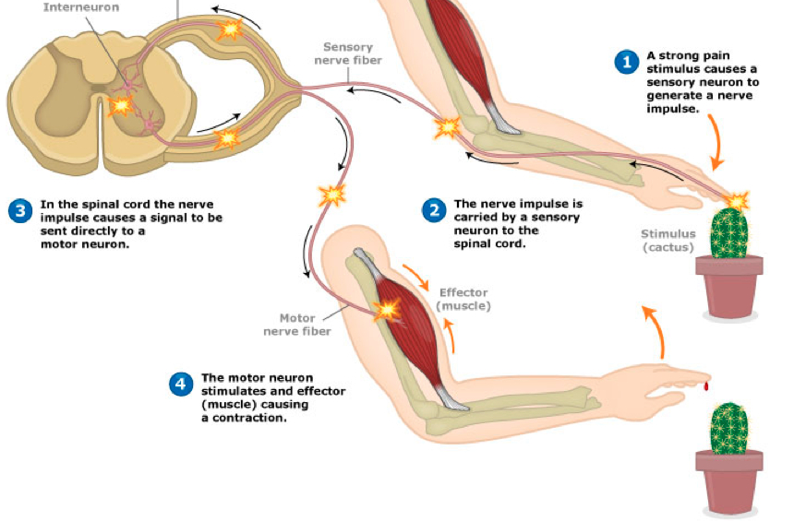

* **Transmission of nerve impulses is via electrochemical changes that occur at the generation of the impulse, the propagation of the impulse along the nerve fiber, and the transfer of the impulse across the synapse**

Neurons have a voltage difference inside and outside the membrane. The voltage difference is used to make an impulse. Nerve conduction depends on the movement of ions across the cell membrane. A membrane has electrical potential difference known as voltage. The cytoplasm (inside of cell) is more negative relative to the extracellular side(outside of cell). This forms potential energy A.K.A a **membrane potential**. The resting membrane potential of most unstimulated neurons is -70mV.  
  
The resting membrane potential provides enough energy for a nerve impulse to occur in response to a stimulus. The process of a membrane potential returning to its resting membrane potential of -70mV is called **repolarization**. Neurons become polarized because of different processes occurring at once. The charge is separated to achieve a potential difference because of the following reasons;

1. The negatively charged organic molecules such as proteins inside the cell are too large to pass through the membrane so they inside is the cell is maintained as negatively charged.
2. The sodium-potassium pump uses ATP energy to transport 3 Na+ outside the cell for 2 K+ going inside the cell. This causes an excess is positively charged ions outside the cell
3. Sodium and potassium ions also use passive transport to enter and leave the cell. The potassium diffuses outside the cell more easily than sodium entering the cell leaving the inside of a neuron more negative.

The resulting membrane potential from these 3 processes becomes about -70mV

The resting membrane potential keeps the axon ready for an impulse; the energy for the impulse is stored in the electrochemical gradient.

**Action potential**

A nerve impulse is of a series of **action potentials**. Action potentials take place on a tiny segment of the axon membrane beside each other and take a few milliseconds to occur. It is the rapid depolarization and repolarization of a cell membrane

Depolarization occurs if the membrane potential becomes higher than -70mV. This occurs when a strong enough stimulus acts on the neuron. This happens because the amount of positively charged Na+ ions enters the cell and lessens its negativity.

The action potential is referred to an **all-or-none** response since if a certain threshold is reached then the same response occurs no matter how large the stimulus is. The usual threshold for most neurons is -55mV although it can vary slightly.

When thresholds are reached; special structures in the membrane called **voltage-gated sodium channels** are opened which make the membrane very permeable to the Na+ ions coming from the outside and it causes the inside of the cell to become more positive than the outside of the cell.

When the membrane potential reaches +35mV; the voltage-gated sodium channels close and the **voltage-gated potassium channels** open the potassium will move down its gradient so it will go to the outside where there is less concentration of it. As positive charged ions are released from the membrane the membrane potential increases all the way to -90mV. At this stage, the voltage gated potassium channels close. By passive transport, the potassium ions slowly diffuse through the cell membrane into the cell returning its membrane potential to its resting membrane potential of -70mV.

**How do action potentials stimulate each other?**

In unmyelinated fibers, when the nerve is stimulated, the membrane becomes more permeable to sodium ions which mean the resting action potential is disturbed and it becomes less than -70mV. If the threshold of about -55mV (depending on the neuron) is reached. Special structures in the membrane called voltage gated sodium channels open and large amounts of Na+ enter the cell which make the inside more positive than the outside which eventually cause the membrane potential to become about 30mV. Once this is reached, the voltage gated sodium channels close and the voltage gated potassium channels open. Since there is a high concentration of Na+ ions, they move to an area with less concentration so to move down their gradient. The will move in both directions but it will not cause an impulse where an action potential just took place as it is still in the refractory period. The refractory period is when a nerve impulse cannot be stimulated in a specific location, where an action potential already occurred, for a few milliseconds. The positive Na+ ions cause depolarization to occur on an area beside the area that last experienced an action potential. In myelinated fibers however, the same thing occurs but instead of depolarization occurring right beside the last area of the action potential. It occurs at the next node of ranvier since there are the axon membrane is covered in a white fatty material called the myelin sheath and an action potential cannot occur there. This occurs until the axon terminals are reached.

**How to impulses travel from neuron to neuron?**

A **synapse** is a small gap that forms a connection between two neurons or a neuron and an effector. Special chemicals called **neurotransmitters** are enclosed on synaptic vesicles that move towards and fuse on the pre-synaptic membrane. The neurotransmitters are released from the vesicles by exocytosis when the action potential takes place and calcium ions flow into the pre synaptic cell. They diffuse through the synaptic cleft taking about 0.5 to 1 ms and bind to the specific receptors on the post synaptic cell. The receptor proteins trigger ion specific channels such as sodium channels to open and depolarization occurs on the post synaptic cell If the threshold is reached. The impulse continues along the nerve fiber. The neurotransmitter is destroyed after the impulse has taken place. This continues until the effector structure is reached and the desired response is made.

**Examples of neurotransmitters** **are**; adrenaline, noradrenaline, dopamine, histamine, acetylcholine etc.

* **Structures and function of the division of the nervous system can be observed and compared at different levels in detecting and responding to changes in the internal and external environment.**

The two main divisions of the nervous system are the central nervous system (CNS) and the peripheral nervous system (PNS). The PNS is further divided into a sensory division and a motor division. The motor division is divided into two components; the autonomic and the somatic divisions. The automatic division is further divided into a sympathetic division and the parasympathetic division

**The central nervous system**

It is the control centre that includes the brain and the spinal cord. Information is sent here to be processed and sent out.

**The peripheral nervous system (PNS)**

-They are the nerves that bring impulses to the CNS from muscles, joints and organs  
-The nerves that connect the effectors such the muscles, organs and glands to the CNS  
-Consists of groups of cell bodies called ganglia  
-There are 12 pairs of cranial nerves that arise from the brain.  
-Most cranial nerves are mixed nerves as they have sensory and motor neurons combined.

-A few cranial nerves carry only sensory impulses or motor impulses.  
-There are 31 pairs of spinal nerves that arise from the spinal cord  
-All spinal nerves are mixed nerves that are joined to the spinal cord by two roots.  
-Ventral root consists of motor neurons that have the cell bodies in the grey matter of the spinal cord  
-Dorsal root consists of sensory neurons that have their cell bodies inside of a swelling on a dorsal root called the dorsal root ganglion.

The Peripheral nervous system consists of different divisions that help it function as a whole.

**Sensory division (afferent)**

The afferent neurons carry information from the receptors on the joints, muscles and organs to the CNS where they are processed. The nerve cells from the body are called **somatic sensory neurons**. The nerve cells from the organs are called **visceral sensory neurons**.

**Motor division (efferent)**

The efferent neurons carry information from the CNS to the effector structures such as muscles, organs and glands.

The motor division is subdivided into an **autonomic division** and **somatic division**

**Somatic division (somatic nervous system)**

Takes impulses from CNS to skeletal muscles and skin

**Autonomic division (autonomic nervous system)**

Takes impulses from CNS to organs, glands and skeletal muscles

The autonomic division is further subdivided into a sympathetic division and a parasympathetic division

**The autonomic nervous system (ANS)**

-The autonomic nervous system controls the body internal environment and it involved with mechanisms that are involved in keeping the body’s internal environment constant.

-It is regulated by groups of nerve cells in the medulla oblongata, hypothalamus and the cerebral cortex

**Functions regulated by the autonomic nervous system** **are**;

Body temperature, digestion, release of energy, release of digestive juices, diameter of pupils of the eye, heart rate, blood flow, air flow to lungs, defecation and urination.

-Nerve fibers of ANS make up part of spinal nerves and part of cranial nerves.

-The **autonomic pathway** from CNS to the effector consists of **2 motor neurons**. 1 has their cell body in the CNS and 1 in a ganglion.  
  
-The **somatic pathway** from CNS to the skeletal muscle consists of **1 motor** **neuron** with no synapse and no ganglion.

The **neurotransmitter** for the autonomic pathway is either **acetylcholine** or **noradrenaline**.

-Most organs under autonomic control have two sets of nerve fibers; sympathetic nerve fibers and parasympathetic nerve fibers.

-The **parasympathetic division** produces responses that **maintain the body** in quiet conditions and releases acetylcholine.

-The **sympathetic division** produces responses that **prepare the body** for strenuous activity such as engaging in aggressive behavior and fleeing from a threat. It releases noradrenaline.

In a threatening situation. The balance between sympathetic and parasympathetic is broken and sympathetic nervous system becomes more dominant since the fight-or-flight response occurs.

**Dominance** in the **sympathetic nervous system** results in:

-Increased rate and force of heart contraction so consequently blood pressure is increased.  
-Blood vessels involved in strenuous physical activity (heart, skeletal muscles, liver) dilate and blood vessels of organs not involved in physical activity (kidney, stomach, intestines, skin) constrict.  
-Airway in lungs increases so rate and depth of breathing increases.  
-Liver converts more glycogen into glucose so blood glucose level increases.  
-Sweat secretion increases.  
-Adrenaline and noradrenaline is released which intensify responses

Similarities between the endocrine system and the nervous system:  
-Some substances function as both hormones and neurotransmitters.  
-Some hormones such as oxytocin and adrenaline are secreted by neurons.  
-Some hormones and neurotransmitters have same effect on same target cells. Noradrenaline and glucagon cause glycogen to be broken down into glucose.

* **Cell replacement therapy has the potential to treat nervous system disorders including Alzheimer’s and Parkinson’s disease.**

**Alzheimer’s disease**-The neurons in the cerebral cortex lose mass and shrink. The neurons eventually die out and they’re will be fewer synapses so communication between neurons is affected.  
-The fluid filled cavities (ventricles) in the centre of the brain grow larger while cerebral cortex and hippocampus shrinks.

Plaques  
-Plaque is formed from protein molecules called beta amyloids. The beta amyloids come from large protein molecules found in the fatty material surrounding the neurons.  
-The beta amyloidal proteins are chemically sticky and they build up into proteins.  
-Plaques interfere with nerve cell communication as they block the neurotransmitters diffusing from the synapse  
  
Tangles  
-Healthy neurons have a transport system made out of parallel microtubules that transport food molecules, cell parts and key materials along the neuron.  
-A protein called Tau binds and stabilizes the microtubules.  
-When the Tau collapses the microtubules become twisted and these are called tangles.  
-The microtubules are no longer straight so food molecules and key materials cannot be transported so the neuron eventually dies out.  
  
Progression of plaque and tangles in the brain leads to decreased;  
1. Learning and memory.  
2. Speech and understanding speech.  
3. Your position relative to the object around you.

In Alzheimer’s the production of neurotransmitters is affected; particularly acetylcholine. Production of Noradrenalin is also reduced but different mechanisms can increase it again.  
In younger children, much more different neurotransmitters are affected.

**Parkinson’s disease**-It is a disease that degenerates the CNS. The midbrain has a basal ganglion that has dopamine generating cells that die when you have Parkinson’s disease.

Symptoms: shaking uncontrollably, slowness of movement, sensory problems, rigidity, dementia and difficulty walking

Causes: It is Impossible to predict as there are no known causes.  
  
Therapies: Drugs increase the level of dopamine in the brain by stimulating areas that produce dopamine and inhibits the areas that effect the production of dopamine

**Cell replacement therapy**

A person who experiences a loss of or injury to cells can undergo **cell replacement therapy.** The transplanted neurons to the brain grow and develop connections to other neurons. Tissue engineering or cell replacement therapy is an option if the patient wants to avoid transplanted tissue or organs.

Injecting genetically modified disease-free cells directly into the brain via a natural or synthetic **scaffold** so they can grow into tissue. The stem cells are first cultured (grown) to reproduce **nerve growth factor** and seeded into the scaffold. The scaffold contains large pores for the tissue to grow and to obtain nutrients from the body. The scaffold has to be prepared so that the rate of biodegrading of the scaffold matches the rate of the tissue formation. The modified cells reproduce into NGF (nerve growth factor). It is a natural substance. That repairs, grows and helps with the survivability of the neurons in the brain. It slows the disease down by 50%.

* **Different receptors detect change in the internal and external environments, including thermo receptors, osmoreceptors, chemoreceptors and receptors for touch and pain.**

A **receptor** is a structure that is able to detect changes to the boy’s internal or external environment.  
  
Receptors cells are grouped together to form a **sense organ**. Examples of sense organs are the light receptors in the eye or the receptors that are sensitive to the sound vibrations in the ear.Some receptors are simple **nerve endings** that are found through parts of the body or are in the whole body; **examples** are pain or temperature receptors in the skin.

**These are the different types of receptors  
  
Thermoreceptors**-These detect changes in temperature inside or outside the body, they are found in the skin.  
-Messages are sent to the hypothalamus and cerebrum  
-There are receptors that deal with heat only and receptors that deal with cold only.  
-The temperature inside the body A.K.A central thermo receptors are monitored by thermo receptors found in the hypothalamus. It does this by detecting the temperature flowing to the brain. Central thermoreceptors are found in the organs, spinal cord and hypothalamus.  
-Detects information from the peripheral thermoreceptors in the skin   
  
**Osmoreceptors**  
-These receptors are sensitive to the changes in osmotic pressure.  
-They stimulate the hypothalamus on any small changes in the concentration of dissolved substances in the water of the blood plasma

**Chemoreceptors**-These receptors are stimulated by certain chemicals  
-They are present in the nose to increase our sensitivity to smells and mouth to give us sensitivity of tastes  
-There are internal chemoreceptors that are sensitive to what’s in the bodily fluids

-Some chemoreceptors are in blood vessels that detect changes in the pH of the blood and concentration of oxygen and carbon dioxide.

**Touch receptors**-These are mainly found in the skin and there are many types of touch receptors  
-They are close to the surface of skin and are sensitive to very light touches; they are mainly found in the palms of hands, in the check, underneath feet, external genital organs, lips, fingertips, eyelids.  
-Nerve endings are found at the base of hair follicles.  
-Touch receptors close to the skins surface and nerve endings attaches to hairs adapt very rapidly.  
-After a few milliseconds the sensations are gone.  
-Other touch receptors are found deep in the skin and are sensitive to changes in pressure and vibrations  
  
**Pain receptors (nociceptors)**-They are mainly found in the skin and mucous membranes.  
-They are stimulated by damage to the tissues; such as from a cut or a heavy bump, by poor blood flow to a tissue or by stimulation from stimuli; such as heat, chemicals or electricity.  
-Pain warns the person that damage is occurring and evasive action or medical attention is needed.  
-Pain receptors adapt either very little or not at all.  
-The failure of pain receptors keeps the person aware that his tissues are being damaged.

* **The nervous and endocrine systems work together to coordinate functions of all body systems, but differ in terms of speed of action, duration of action, nature and transmission of message and specificity of message.**

**The speed of action:**

* **Nervous system:** The nerves send impulses which are almost instantaneous. They last only a few milliseconds.

**Endocrine system:** The glands secret hormones that take from a few seconds to a few days to months to make an effect on the body. A few seconds would be adrenaline. A few months would be estrogen, progestogen and testosterone.

**The duration of action**:

**Nervous system:** The impulses from the nervous system last a few milliseconds**.  
Endocrine system:** The hormones from the glands can last for a few seconds to months.

**Nature and transmission of message:  
  
Nervous system:** The message is an electrical impulse that travels through neurons and gets transferred from synapse to synapse by chemicals called neurotransmitters.

**Endocrine system:** The hormones are chemicals that are in the form of proteins, lipids or steroids that travel through the bloodstream to the target organ.

**The specificity of the message**

**Nervous system:** impulses are specific to certain locations such as a muscle fiber or gland cells.

**Endocrine system:** They can affect multiple parts of the body; they can be widespread.

**Homeostasis**

* **Homeostatic processes involve nerves and hormones that keep the body’s internal environment within tolerance limits through the control of metabolism and physiological and behavioral activities.**

The body’s internal environment needs to be maintained between narrow limits for it to function properly. This is called homeostasis. Homeostasis is achieved by the nervous system and the endocrine system working cooperatively. The limit to which factors can fluctuate up and down a set point before homeostatic processes occur is called tolerance limit.

An example of a tolerance limit is the temperature. The body’s core temperature set point is 37.8 degrees and if a change in temperature is above or below this then responses such as shivering or taking off pieces of clothes will occur. This is done to maintain the temperature; Hence, maintaining homeostasis.

* **Different receptors detect change in the internal and external environments, including thermo receptors, osmoreceptors and chemoreceptor’s.**

A **receptor** is a structure that is able to detect changes to the boy’s internal or external environment. Receptors cells are grouped together to form a **sense organ**. Examples of sense organs are the **light receptors** in the eye or the receptors that are **sensitive to the sound** **vibrations** in the ear.Some receptors are simple **nerve endings** that are found through parts of the body or are in the whole body; examples are **pain** or **temperature receptors** in the **skin**.

Some receptors are grouped together as bodies such as **chemoreceptors** in the medulla oblongata, aorta and carotid artery. The aortic and carotid body’s chemoreceptors detect changes in H3O+ concentrations and the medulla oblongata’s chemoreceptors detect changes in concentrations of CO2. **Thermoreceptors**these detect changes in temperature inside or outside the body, they can be found on the skin, organs or hypothalamus. The peripheral thermoreceptors are found on the skin and the central thermoreceptors are found in the hypothalamus, internal organs and spinal cord. Messages are sent to the hypothalamus and cerebrum. There are receptors that deal with heat only and receptors that deal with cold only. The temperature inside the body A.K.A core temperature is monitored by thermoreceptors found in the hypothalamus. It does this by detecting the temperature of the blood flowing to the brain. The hypothalamus regulates body temperature by detecting the information from the thermoreceptors in the skin and hypothalamus.  
  
**Osmoreceptors**  
These receptors are sensitive to the changes in osmotic pressure. They stimulate the hypothalamus on any small changes in the concentration of dissolved substances in the water of the blood plasma such as Na+, Cl-, K+.

**Chemoreceptors**They are present in the nose to increase our sensitivity to smells, mouth to give us sensitivity of tastes, carotid and aortic body’s to detect changes to H3O+ concentrations, medulla oblongata to detect changes in CO2 concentrations, aortic detects changes in O2 and CO2 while carotid bodies detect changes in all three

**Baroreceptors**these detect the stretch of the blood vessels so they send signals to the hypothalamus that blood pressure has changed. They can cause the blood to increase cardiac output.

* **Thermoregulation occurs through the control of heat exchange and metabolic activity through nervous, endocrine and behavioral systems.**

**Thermoregulation** is a process that allows your body to maintain its core temperature. It does this by making sure the **heat gained = the heat lost.** Increased body core temperature can cause nerve malfunction, change of protein structure and death.

Once the heat thermoreceptors in your skin or hypothalamus get stimulated because of exercise, fever or digestion or simply being in hot environment; an impulse is sent through the sensory neurons that go through the dorsal root up the ascending tract of the spinal cord to the thermoregularatory centre in the hypothalamus. The hypothalamus then sends an impulse that travels through motor neurons in descending tract of the spinal cord out of the ventral root to the effectors organ. The effectors organ can be the muscle fibers surrounding the blood vessels near the skin to increase the diameter to increase the flow of blood to the skin so the heat can be radiated out into the environment so colder blood comes back to the internal organs to keep the core temperature at its set point of 37.8 degrees. The effector organ can be the sweat gland so sweat (H2O, urea, salts, and lactic acid) is released to evaporate on the skin to decrease the skin’s temperature. The hypothalamus will release TSH and ACTH inhibiting factors so TSH does not reach the thyroid so the secretion of thyroxine is decreased and ACTH does not reach the adrenal glands so secretion of adrenaline and noradrenaline is decreased. This occurs because the hormones thyroxine, adrenaline and noradrenaline increase the metabolic processes on the body to produce heat and that is not what the body wants. The cerebrum is also stimulated so behavioral responses such as taking off layers of clothing, turning on the air conditioner and decreasing physical activity can occur.

If the temperature is decreased such as during drug use, alcohol use or simple being in a cold environment; The cold thermoreceptors in your skin or hypothalamus get stimulated and impulse from the skin cold thermorecptors travels through sensory neurons to the dorsal root up the ascending tract of the spinal cord to the thermoregularatory centre in the brain which will send and impulse through the motor neurons in the descending tract out of the ventral root to the effect organs. The effector organs can be the muscle fibers that wrap around the blood vessels near the skin to contract them so blood does not flow to the skin to be radiated instead it stays near the internal organs keeping the core temperature at its set point of 37.8 degrees; this process is called vasoconstriction. The effector organ can be the arrector pili muscle that contract to cause the hair near the skin to experience piloerection so the skin over the air becomes dead which serves as an insulator. The effector organ can be the skeletal muscles so contraction causes repetitive tremors called shivering to occur. The shivering increases the oxygen and glucose to be used to create carbon dioxide and energy. The breathing rate will increase and the energy made from cellular respiration will be used to keep the body warm in the form of heat. The hypothalamus will to release TSH and ACTH releasing factors which will cause the anterior pituitary lobe to increase TSH and ACTH production. TSH will reach the thyroid and thyroxine will be released and ACTH will reach the adrenal medulla where noradrenaline and adrenaline is released. All these hormones increase metabolic activity in the cells so energy production is increased and this energy is in the form of heat. Hence, increasing the temperature of the body. The cerebrum can be stimulated so behavioral responses such as turning off the fan, increasing layer of clothing, increasing physical activity and decreasing surface area of body by curling up into a ball can occur.

**Extreme forms of temperature can cause death  
  
Heat stroke**Heat stroke occurs when heat gain is continually higher than heat loss. This occurs when the sweat produced by the person does not evaporate due to humidity so it is difficult to lose heat by radiation or evaporation. This causes the temperature of the person to keep increasing. This can cause swelling of the brain and eventually brain damage.

**Heat exhaustion**Heat exhaustion is when there is extreme sweating and extreme vasodilatation. The water concentration in blood plasma is decreased and the blood vessels are dilated. This decreases the blood pressure so cardiac output keeps increasing which causes the person to collapse.

**Hypothermia**Hypothermia occurs when core body temperature is less than 33 C˚ so metabolic activities cannot replace the heat lost so the temperature then continually falls until death occurs.

* **Synthetic hormones are developed to control or treat endocrine dysfunction diseases hypothyroidism and hyperthyroidism.**

The thyroid releases Thyroxine (T4) and Tri-iodothyronine (T3). They both have the same effect but the major form is Thyroxine (T3)

Thyroxine affects nearly every tissue in the body by stimulating protein, carbohydrates and fat metabolism. In doing so, it regulates the basal metabolic rate (BMR). The BMR is the amount of energy released by body during rest and constant temperature.

Any excess or deficiency of thyroxine can cause homeostasis to be disrupted.

**Hyperthyroidism (Graves disease)**Hyperthyroidism occurs when the thyroid gland produces too much thyroxine continuously. This is because the immune system attacks the thyroid. Graves disease is a common type of hyperthyroidism. The constant thyroxine production causes the cells of the body to become over stimulated so the symptoms include:

Weight loss, increased appetite, high metabolism, heat intolerance to heat, increased heart rate, fatigue, protruding eyeballs (exophthalmia), goitre. OPPOSITE SYMPTOMS OF HYPOTHYROIDISM

**Treatments**

It can be treated radioactive iodine drink where the radioactive iodine attaches to thyroid and it kills the thyroid cells. The excess radioactive waste is lost from body via urine. Surgery can be used to remove some or all of the thyroid gland.

**Hypothyroidism**Hypothyroidism occurs when the thyroid produces too little thyroxine hormone. This occurs either because the immune system mistakenly attacks the thyroid, the radiated iodine has killed a lot of thyroid cells, when thyroid is removed or because there is a lack of iodine in the persons diet.

Lack of thyroxine causes most cells of body to be under-stimulated so the symptoms include:

Weight gain, decreased appetite, low metabolism, decreased heart rate, tiredness, feeling cold, periorbital edema and apathy. OPPOSITE SYMPTOMS OF HYPERTHYRODISM.

**Treatments:**

Hypothyroidism can be treated but not cured. Treatments include high iodine concentrations in diet and thyroxine in tablet form.

Hypothyroidism patients used to be treated with dried up, powdered animal thyroids in tablet form but now synthetic thyroxine is made by chemical process. Levothyroxine is prescribed; it’s a synthetic form of thyroxine (T4)

* **Blood sugar levels are maintained by controlling of sugar uptake, its storage and release by cells and use in metabolism; these processes involve the hormones of the pancreas and adrenal glands.**

Glucose is needed for all cells to gain energy and function optimally. Glucose (C6H12O 6) and Oxygen (O2) combine in the cells to release energy and carbon dioxide and water. Glucose is found in the blood and it travels through the blood to provide energy to cells. Carbohydrates in the body are composed of glycogen which is long chains of glucose. Complex carbohydrates release energy slow sustainable energy while simple carbohydrates release energy quicker and which causes a glucose crash. This occurs because glucose concentration is so high at once, insulin is released to convert glucose into glycogen and that causes a big drop in glucose making you feel tired.

The **pancreas**, **adrenal glands** and **liver** work in an integrated manner to keep the glucose levels in the blood constant.

**Liver**

The liver is a glycogen store house. It converts glycogen into glucose (**glycogenolysis**) and glucose into glycogen (**glycogenesis**). The liver is the first to absorb the glucose from the digested food. The livers blood supply comes from **hepatic portal vein**.

Carbohydrates are broken down in the stomach into glucose it is taken to the liver through the hepatic portal vein and it is either; converted into glycogen, removed from blood to provide energy for liver, allowed to keep flowing through body providing energy for cells. The liver can convert amino acids, fatty acids, lactic acid into glucose.

The liver stores 100 grams of glycogen for short term energy supply and the muscle cells stores 400 grams of glycogen.

**Pancreas**

The pancreas contains the **islets of langerhans** and these are composed of either beta cells or alpha cells.

Alpha cells - Alpha cells secret **glucagon**; glucagon converts **glycogen into glucose** in the liver and it also

Beta cells - Beta cells secrete insulin; insulin converts glycogen into glucose in the liver. It also allows the body cells to take in glucose more readily. Increases fat storage by converting glucose into fat in fat tissue. It increases protein synthesis.

**Adrenal glands**

The adrenal medulla secrets two hormones that help regulate glucose.

Glucacorticoids (cortisol) – Stimulates conversion of glycogen into glucose and breaks down protein into amino acids where they can be transported and then converted to glucose in the liver. It also regulates carbohydrate metabolism so to make sure enough released for the cells.

Adrenaline/Noradrenaline – breaks down glycogen into glucose and stimulates the production of lactic acid in muscle cells to be converted into glucose in the liver.

Gluconeogenesis – breaking down of any molecule other than carbohydrates (glucose)

$\frac{90mg}{100mL}$ = normal glucose level in blood. The limits are 120mg/L-1 and 70 mgL-1 before serious health problems will occur.

The food we consume is broken down inside of the stomach and the digested food makes its way through the small intestine so the nutrients become absorbed by the body. The glucose and fructose pass through the small intestine lining through the interstitial cells into the blood stream. As the glucose level in the blood stream increases the pancreatic receptors detect this and the beta cells of the islet of langerhans in the pancreas release insulin into the blood stream. Insulin then binds to sugar molecules to be able to bind to insulin receptors in the surface of liver cells and muscle cells so glucose can enter the cells and they will be used by cells for energy. Insulin also promotes the conversion of glucose into fat and can promote protein synthesis. Excess glucose will be stored in the form of glycogen in muscle and liver and fat in adipose tissue. As glucose concentration in the bloodstream is low, the alpha cells in the islet of langerhans of the pancreas secrete glucagon which will convert glycogen in the liver cells and muscle into glucose to increase blood glucose level. Glucagon also promotes gluconeogenesis which is the process of converting amino acids, fatty acids and lactic acid into glucose in the liver. If blood sugar is still low for example when exercising or being in a fight-or-flight state; the sympathetic nerves of the Autonomic nervous system become dominated and they stimulate the adrenal medulla to release adrenaline and noradrenaline. Glucacorticoids, adrenaline and noradrenaline is released. Cortisol (glucacorticoids) increases rate proteins and broken down in the muscle into amino acids to be converted into glucose in the liver and stimulates conversion of glycogen into glucose. Adrenaline and noradrenalin stimulates break down of glycogen into glucose in the liver to be released in the bloodstream and they stimulate production of lactic acid in muscles for it to be converted into glucose in the liver.

**Synthetic hormones are developed to control or treat diabetes mellitus (diabetes), gene therapy can be used to treat a range of diseases including diabetes mellitus (diabetes).**

**Diabetes type 1 (ASBNKH)**

Occurs when not enough insulin is released by the beta cells of the islet of langerhans of the pancreas. This usually because of the immune system mistakenly attacks the beta cells causing them to be destroyed and no more insulin is released. As a result, blood glucose increases.

Treatments for this disease including carrying around insulin pumps that pumps insulin constantly especially after meals are taken so insulin can enter the cells and decrease blood glucose level. Insulin can be digested so it not taken in pill form.

If type 1 is untreated the symptoms are (**ASBNKH**); kidney failure, heart attack, stroke, amputation, blindness or nerve damage.

**Diabetes type 2**

Diabetes type 2 occurs when the insulin receptors in the cells become desensitized to glucose, causing blood sugar to increase in the blood vessels which can eventually cause damage to the blood vessels.

Risk factors; age over 45, lack of physical activity or healthy diet, smoking, being overweight, high cholesterol. This disease is known as the “lifestyle inflicted disease”  
  
Treatments include lifestyle changes such as exercise and a good diet, taking tablets to sensitize the insulin receptors and to add more insulin to overcome the desensitized insulin receptors, decreasing sugar and salt in the diet.

If type 2 is untreated; foot problems, heart disease, kidney failure, stroke or nerve damage.

**Synthetic insulin hormone**

Insulin used by extracted from the pancreas of cows and pigs but people became infected and experience allergic reactions. In the 1980’s insulin was made by getting the gene that made insulin from a DNA sample and inserting it in a bacterial cell. The bacterial cell was allowed to reproduce and large amounts of insulin were made from this way. Yeast is now used to make insulin.

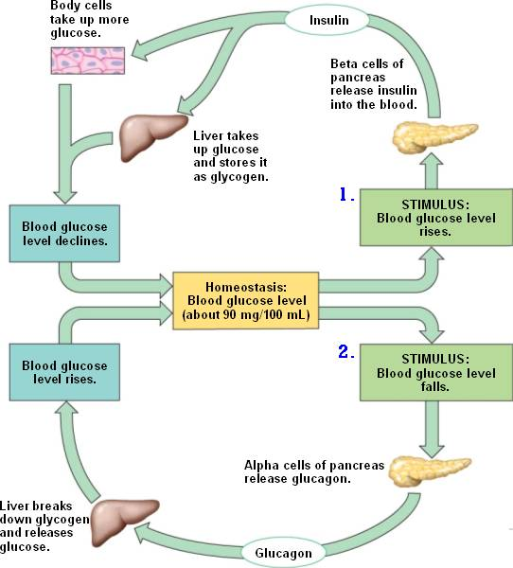

* **Body fluid concentrations are maintained by balancing water and salts via the skin, digestive systems and the kidneys, which involve the actions of the antidiuretic hormone (ADH) and aldosterone on the nephron.**

The kidney regulates the concentrations of the fluid in the body and it prepares it for excretion. When the osmoreceptors in the blood vessels get stimulated, they send an impulse to the hypothalamus to either increase/decrease aldosteone/ADH secretion in order to return the composition of fluids to optimal concentrations. When blood reaches the kidney; the glomerulus uses high pressure to constrict the blood and all the small molecules such as urea, glucose, toxins and water will make their way through the capillaries to the bowmans capsule. Large molecules such as red blood cells stay in the blood. The filtrate (all fluid in nephron is filtrate) will travel along the proximal convoluted tube. The PCT is where 70% of all the molecules such as urea, glucose, water, salts and amino acids are absorbed. When the filtrate goes down the descending limb of the loop of henle, water will diffuse out because of osmosis so the filtrate becomes really concentrated. This is because the descending limb is only permeable to water. In the ascending limb of the loop of henle it is not permeable to water unless water is attached to Na+ when the hormone aldosterone causes Na+, with some water molecules attached to it causes blood volume to increase, to be reabsorbed and K+ to be secreted. The distal convoluted tubule contains Na+ and Cl- pumps so salts are secreted from ascending limb to the tissue fluid so it can go down its concentration gradient. Further up the ascending limb it will require active transport for the salts to be secreted from ascending limb. At the distal convoluted tubule, more nutrients are secreted into tubule. When reaching the collecting duct, the water either is excreted from body when the body is hydrated, this means the aqua porin channels are closed and water is free to become urine. Or the body is dehydrated and the aqua porin channels are open which means water can be reabsorbed back via osmosis to the body from the collecting duct. The secretion of ADH causes the aquaporin channels to open.

**The fluid composition of body**

**The fluid in = the fluid out**

**Fluid intake Fluid out**Drinking = 1000mL Urine = 1200mL  
Food = 1200mL Sweating = 750mL  
metabolic water = 300mL Breathing = 400mL dds Feaces = 150mL

Total = 2500mL Total = 2500mL

**Composition of water in cells**

**2/3 is intracellular (inside cells)  
1/3 is extracellular (outside cells)**3/4 is interstitial fluid (between cells)  
1/4 is in plasma

**Intracellular = 21 Liters**  
**Extracellular = 17.5 Liters**

**TOTAL = 38.5 Liters**

The human adult male body is on average 60% water and 30 % tissue fluid and 8% blood plasma 1% other. The adult female has about 55% of water. The body does not want K+ increasing in the blood.

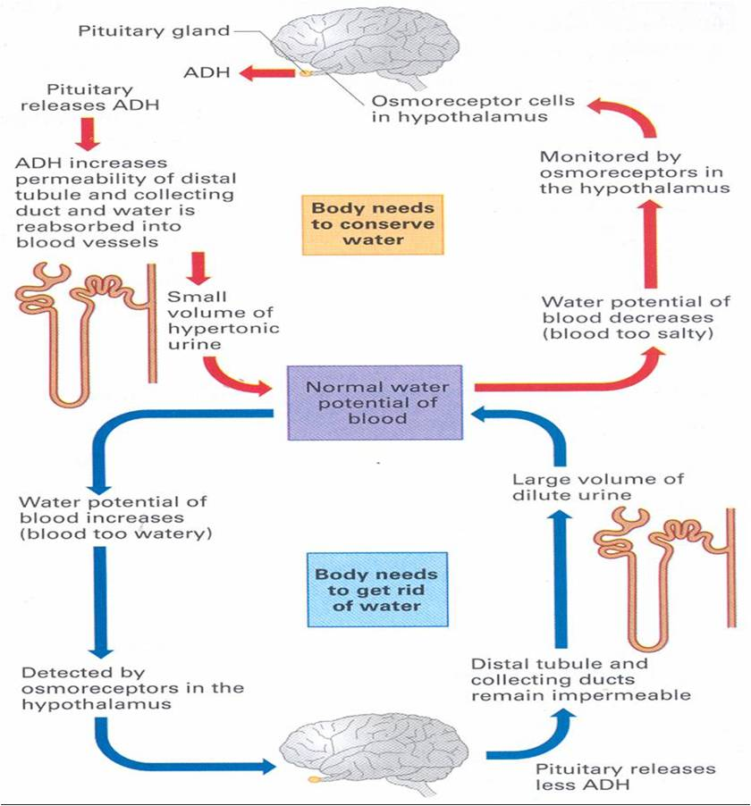 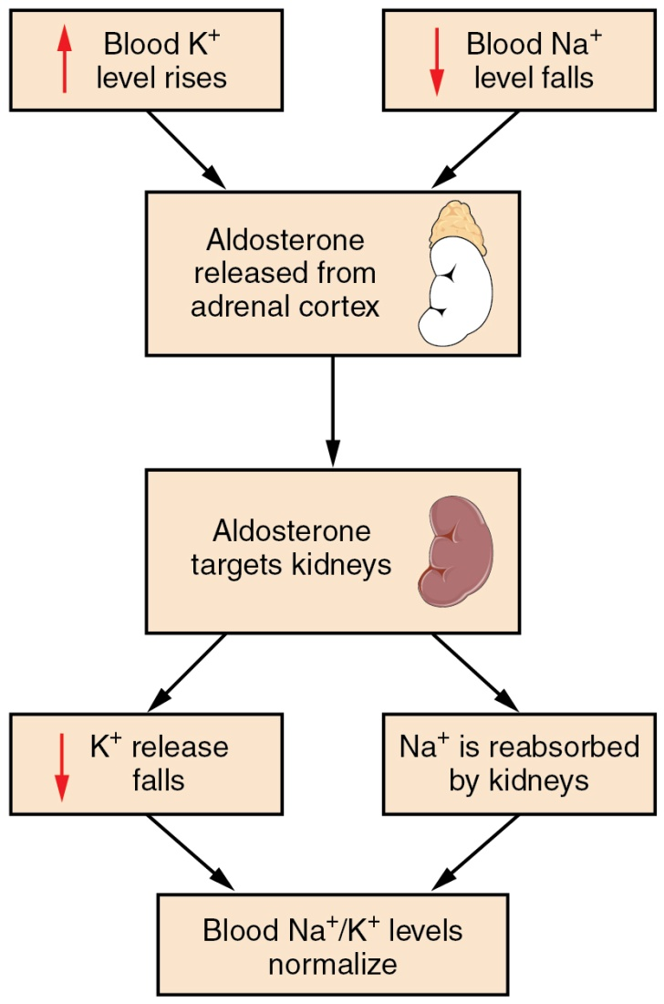

**Fluid circulation in capillaries**

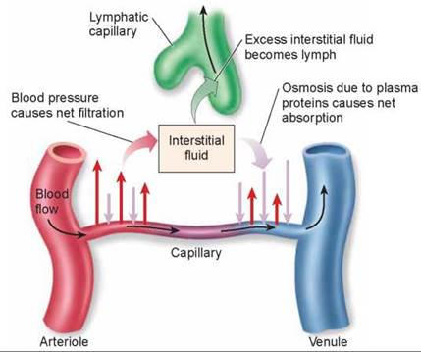

Hydrostatic pressure is greater than osmotic pressure so nutrients flow out of the blood into the interstitial fluid.

Osmotic pressure is greater than hydrostatic pressure so water flows into the blood in capillaries.

Dehydration:

Dehydration occurs when water loss is greater than the water gain. This can occur from extreme sweating, vomiting and diarrhea.

Symptoms: dizziness, thrist, low blood pressure and headache.

Water intoxication:

Water intoxication occurs when water gained is more than water lost. This occurs when drinking plain water that doesn’t have any electrolytes right after losing a lot of water from body.  
Symptoms: light headedness, vomiting, headache and collapsing.

* **Gas concentrations are controlled by balancing the intake of oxygen and the removal of carbon dioxide via the lungs, through the actions of the medulla oblongata and the autonomic nervous system.**

As glucose is used up by the cells to release energy through cellular respiration, CO2 is produced. CO2 is harmful when in high concentrations in the body so it is lost through the process of breathing.

When breathing in: 21% is oxygen and 0.04% is CO2  
when breathing out: 15% is oxygen and 5% is CO2

During exercise the muscles work harder so more oxygen is needed to produce energy. A waste product of this process of cellular respiration is the build of CO2 levels in the blood. The CO2 reacts with water in the blood to form H2CO3 and it eventually disassociates into H3O+ ions so the chemoreceptors in the aortic and carotid bodies detect the changes in pHand it sends an impulse through the vagus nerve to the inspiratory centre (the dorsal respiratory group). The apneustic and pneumotaxic centre become stimulated to increase rate and depth of breathing and the inspiratory centre sends impulses down the phrenic and intercostals nerves to insipiratory muscles such as the external intercostals muscles and the diaphragm causing them to contract as the impulses are being sent down for 2 seconds. After this occurs the inspiratory centre stops is suppressed and impulses stop sending down which means the inspiratory muscles relax and the expiratory muscles start to contract for 3 seconds. The exhalation muscle contract without the stimulation from the expiratory centre as it is only stimulated during forced breathing. While this is occurring, deoxygenated blood travels from the pulmonary vein in the heart to the alveoli in the lungs to take in oxygen from the air into the blood and CO2 is released to the air from the blood because of the high concentration gradient. Oxygen is then transported all over the body through the blood stream by being attached to hemoglobin now called oxyhemoglobin. This process decreases CO2 concentration which means it increases pH in the blood to optimal levels in the body. The oxygen is used to combine with glucose in the cells to produce energy and further CO2. This process continues to maintain homeostasis of CO2 levels in the blood during strenuous activity.

**The control centers in the medulla:**

The Medulla’s Respiratory centre has 2 centers: the inspiratory centre and the expiratory centre

The **pneumotaxic** centre increases **depth of breathing**  
The **apneustic** centre controls **rate of breathing**

**Automatic breathing (costal breathing):**

Inspiratory centre is stimulated

Exhaling is passive and inhaling is active

**Forced breathing (diaphragmatic breathing):**

Inspiratory and expiratory centers have to be stimulated.

Exhaling is active and inhaling is active

The **respiratory minute volume** (**RMV**) is how much air the lungs take in each minute. It is calculated by:

Tidal volume x Breathing rate = RMV

(The amount of air taken in and out each respiratory cycle) x (the number of times a breath is taken each minute)

**Hyperventilation**

Hyperventilation is the rapid breathing in and out of air that causes the body to take in too much O2 than required and to breathe out more CO2 than necessary. This is usually caused from severe pain or anxiety attack but it can be done voluntarily. CO2 levels eventually go back to normal. This is dangerous to do before going underwater as the lack of O2 can cause the person to become unconscious underwater leading to downing.

**====================================================**

**RESPONSE TO INFECTION**

**=======================================**

* **The body’s external defence mechanisms against pathogens include features of the skin, digestive tract, urogenital tract, respiratory tract, the ear and the eye.**

**Skin**

The skin is an external physical barrier against pathogens. Its surface is slightly acidic and it contains millions of unharmful bacteria. It has oil glands that secret sebum. Sebum kills bacteria. The sweat glands secrete sweat which is also acidic and kills pathogens.

**Digestive tract**

The digestive tract has strongly acidic substances in the stomach that kill pathogens. Some bacteria such as *salmonella* and *helicobacter pylori* thrive in acidic environments however. The digestive tract is also lined which mucous membranes. Lysozymes which are enzymes that kill bacteria are found in saliva, tears, tears and nasal fluids.

**Urogenital tract**

Urogenital tract has the urethra and vagina where acidic urin flows out that kills bacteria. The urogential tract also is lined with mucous membranes

**The respiratory system**

Cilia are hair like projection from cells that are capable of beating motion. The mucous membranes lining the nose cavity, the trachea and other air passages have cilia. The beating of cilia moves bacteria that are trapped in mucous up the throat where it is then either coughed up or swallowed.

**Mucous membranes**

Mucous membranes line body cavities that are open to the exterior. Mucous membranes secrete mucous that traps micro-organisms and particles from entering the body. The whole digestive and urogenital tracts are protected this way.

**The ear**

The ear contains cerumen (earwax) which is composed of lysozymes and it slightly acidic. It also traps bacteria from entering the internal ear

**Hair**

Hair is found in the nose and ears. Hairs and mucous in the nose trap up to 90% of inhaled particles from entering the body.

* **Transmission of pathogens occurs by various methods, including through direct and indirect contact, transfer of bodily fluids, disease specific vectors and contaminated food and water.**

**Direct (contagious) and indirect contact**

Pathogens can be spread by direct contact which is done when directly touching the infected person. Indirect contact is when touching an object that has been touched by an infected person.

**Transfer of bodily fluids**

Pathogens can be spread from someone else’s infected bodily fluids coming into contact with you mucous membranes, nose, mouth, throat, genitals. Pathogens can reach the uninfected bloodstream via dirty needles or break of skin barrier and cause it to become infected

**Disease specific vectors**

Specific vectors (carriers) of disease can be spread by insects. Malaria and dengue fever is spread by mosquitoes, trypanosomiasis is spread by tsetse fly , Lyme disease is spread by ticks and plague is spread by flees from rats and mice.

**Contaminated food and water**

Contaminated food and water get be ingested to cause disease. Dysentry, typhoid fever and salmonella food poisoning is spread by ingesting contaminated food and water with bacteria.

* **Infectious diseases caused by invasion of pathogens in the form of virus and bacteria can be transmitted from one host to another.**

Infectious disease A.K.A communicable diseases A.K.A transmissible diseases are diseases which are caused by foreign substances invading the body and multiplying there. Disease causing organisms are known as pathogens. Diseases are contagious when they are spread by direct or indirect contact from person to another. Diseases can also be spread by vectors such as mosquitoes, ticks or fleas.

* **Pathogens that enter the body are targeted by non specific immune responses such as Inflammation and fever.**

Inflammation occurs when there is mechanical damage or chemical changes to parts of the body. Inflammation is composed of swelling, redness, pain and temperature rise. The suffix ‘*Itis'* is given for any disease that causes inflammation.Such has hepatitis or gingivitis.

The process of swelling is as follows:

New cells are produced by mitosis and repair of damaged tissue occurs.

Mechanical damage or chemical change

The dead phagocytes containing bacteria and cell debris form a white substance called pus

Mast cells release heparin which prevents clotting even though clotting does form around infection site to prevent pathogens from escaping and histamine which causes blood flow to site and increased permeability of blood vessels.

Mast cells release chemicals that attract phagocytes that engulf and digest pathogens

The abnormal conditions stimulate nocireceptors

**Fever**

Fever is the resetting of the body’s thermostat due to white blood cells producing pyrogens during an inflammatory response to a foreign intruder which cause the hypothalamus to reset the body’s thermostat. High temperature fever is thought to be useful as it increases the rate at which cells repair themselves and also denatures proteins of bacteria that live at a specific temperature which causes them to die.

Pyrogens produced by white blood cells do the following to the body:

During infection the body’s thermostat becomes set abnormally high

Body temperature then returns to normal at 37.8˚C

The body’s thermostat is then reset to normal and person feels very hot so vasodilation and sweating occurs.

When temperature reaches ‘crisis point’. Fever occurs

The body feels cold so shivering and vasoconstriction starts to occur. The person wants to warm up

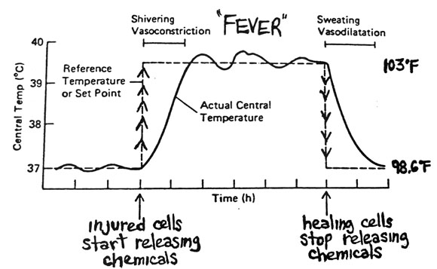

* **Immunity is gained through the exposure of specific antigens by the production of antibodies by B-lymphocyte plasma cells and the provision of cell-mediated immunity by T-lymphocytes; in both cases memory cells are produced.**

Any infectious pathogen that is able to get past the non-specific external barriers and patrolling phagocytes will have to deal with specific defences.

Lymphocytes are invlolved in both specific and non specific responses. 30% of all white blood cells are lymphocytes, most lymphocytes are produced in the bone marrow but some are produced in lymphoid tissue. They have the ability to wander from the tissue into the bloodstream to be transported to another part of the body and then enter the tissues again.

Macrophages develop from monocytes which is a type of white blood cell. They are involved in specific defence by alerting the B cells and T cells to the presence of foreign material.

The immune system protects against foreign organisms, alien chemicals, foreign substances and cancerous and abnormal cells. An immune system response occurs only when B and T cells react to provide protection against a specific antigen.

The immune response in a homeostatic mechanism that restores the internal environment to its normal condition after a specific micro-organism or disease-causing substance is detected.

**Lymphoid tissue**

Most lymphoid tissue is in the lymph nodes but some is the spleen, thymus gland and tonsils. The lymphoid tissue is composed of two types of cells. B-lymphocyte cells and T- lymphocyte cells. Both are produced in bone marrow but **B** cells gain immunological competence in the **bone** marrow and **T** cells gain immunological competence in the **thymus**.

50% of lymphocytes become B cells and 50% of lymphocytes become T cells. They both go to lymphoid tissue after gaining immunological competence. 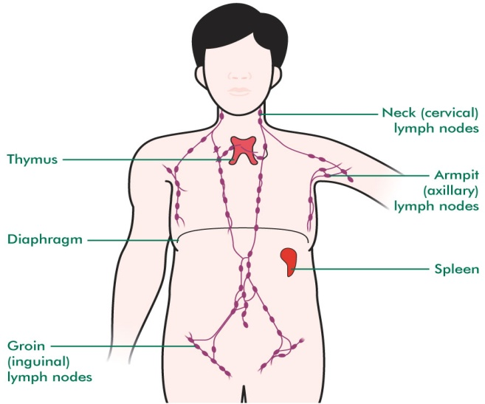

Lymph nodes can be swollen during an infection since lymph can canny cell debris, foreign particles and micro-organisms. Large particles such as bacteria get caught in the mesh work of the fibres in lymph nodes. Macrophages ingulf and ingest particles by using enzymes. It takes 10-30 minutes for macrophages to the destroy cells in this way.

**Antibody-mediated and cell mediated immunity are triggered by antigens**. An antigen is any foreign substance that is capable of produced an immune response. These cause the body to produce antibodies. Antigens may be made out of proteins, carbohydrates, lipids or nucleic acids. **Examples of non-self antigens** are virus particles, bacterial cells, flagella of bacteria, bacterial cell wall, toxins, blood cells of foreign blood group, pollen grains, egg whites, and tissue transplants.

The pathogens travel to the lymph nodes where the B cells only activate if they have matching receptors

**Cell mediated response**

Macrophages and Dendritic cells engulf and partially digest pathogens and then Class II MCH proteins bind to the antigen and transport them to the surface to display their antigens. A cell displaying antigens on their Class II MHC proteins is called an Antigen presenting cell (APC). The antigen is then presented to a helper T cell and cytotoxic T cell that are attracted to the Antigen-MHC complex. The APC will release a cytokine called interleukin 1 to the helper T cell which allows the Helper T cell to secrete another cytokine called interleukin 2 which causes the primed cytotoxic T cell to enlarge and divide into further Cytotoxic T-cells, Helper T-cells, Suppressor T-cells and Memory T-cells.

Cytotoxic T cells

They wonder through the blood to the infection site where they will attach to infected cells and antigens and secret substances that causes them to destruct via apoptosis.

Helper T cells

Play a role in both humoral and cell mediated response. They increase the phagocytic ability of macrophages, they attract macrophages to site of Infection and they intensify the lymphocytes at the infection site.

Suppressor T cells

They release substances that inhibit B cell and T cell activity which causes the immune response to settle down when the infection has been taken care of or when the immune response is too excessive.

Memory T cells

They recognize a past invading antigen and allow a more rapid response which allows T cells to produce much faster.

**Antibody mediated response (Humoral)**

There are billions of B cells that have antibodies bound on them that have a specific type of combination of proteins on the variant part of the antibody. Once an antigen that combines with a specific bound antibody of a B cell; the B cell engulfs and digests the particular antigen. The Class II MCH protein then gets the antigen and displays it on the surface of the cell where helper T cells will combine with the antigens to secrete cytokines which will allow the B cell to divide into plasma cells and into memory cells that are designed specifically to fight of that particular infection. The plasma cells produce massive quantities of specifically shaped antibodies that circulate in the blood and attach to the antigen of pathogens causing them to make an antigen-antibody complex which will mark the antibodies for destruction by macrophages and it blocks active sites on the virus and bacteria the cells making them not being able to bind to receptors of other body cells, meaning no damage is caused. They also cause agglutination causing them to clamp up together and not cause damage to cells.

Antibodies are classified into groups of proteins called immunoglobulin. The classes are IgI, IgD, IgE, IgG, IgM. They have the following effect on antigens:

Neutralization  
Antgibodies bind to active sites on virus and bacteria cells which means they can no longer bind to receptor sites in the body’s cells making them have no effect.

Agglutination  
Antibodies can cause antigen presenting cells to clump together rendering them immobile and harmless to body cells. It also allows phagocytes to consume antigens easier.

Precipitation  
Soluble antigens are made insoluble so they are more easily consumed by phagocytes.

Complement fixation  
foreign cells are tagged by phagocytes for consumption

Antibodies also bind to surfaces virus to make it hard for them to enter cells and coat the surface of bacteria so phagocytes can consume them easier.

* **Passive immunity can be acquired as antibodies gained through the placenta, or antibody serum injections; active immunity can be acquired through natural exposure to the pathogen, or the use of vaccines**

Passive immunity is when antibodies are given to you that are produced from someone else.  
Active immunity is when you produce antibodies to fight an infection.

Artificial immunity requires human intervention by injecting  
Natural immunity requires no human intervention

Active artificial – You produce antibodies after given antigen by human intervention  
Active natural – You produce antibodies after gaining antigens naturally  
  
Passive artificial – Antibodies are given to you when you are given antigen   
Passive natural – Antibodies are given to you when you gain antigens naturally

Passive immunity is immediate since it produces no memory cells.  
Active immunity is longer lasting since memory cells are produced in active immunity. This can last decades or a lifetime.

* **Vaccines are developed using recombinant DNA and associated biotechnological techniques**

**Immunization** is the natural or artificial programming of immune system so that the body can respond to infection micro-organisms. **Vaccination** is the artificial introduction of attenuated virulence (lessened ability to produce symptoms) antigens of pathogenic organisms so the person can produce antibodies without having to fight and suffer from the disease.

There are 4 types of vaccinations:

**Attenuated vaccines**

Attenuated vaccines contain micro-organisms that have reduced ability to produce symptoms (attenuated virulence) so the person can produce antibodies without contracting the disease and feel ill.

**Dead micro-organism vaccine**

This vaccine contains dead microorganisms. It is not very effective as it is short lasting.

**Toxoid vaccines**

Toxoid vaccines are artificially inhibited toxins that have been produced by bacteria so the body can produce antibodies to attack to the toxoids and gain immunization against the toxins

**Sub-unit vaccine**

This vaccine is composed of parts of a bacteria or virus such as the flagella and this acts as an antigen that activates the immune response that allows B cells to produce antibodies against the antigen.

Scientists have found an approach of changing the DNA in the pathogenic micro-organisms cell so they can become less virulent and so then can be used in vaccines. Another technique is to insert the DNA of a pathogen into a harmless bacterial cell where antigens will be reproduced that have the characteristics of the pathogen. These harmless bacteria can then be used for vaccination.

Herd immunization is the immunization of large proportion of people so that it is less likely to be spread in the population even to people who have not been immunized.

Vaccines can be administered as injections via needles, patches (self administered and can be received by mail), sprays, foods and plants.

* **The decision to participate in immunization programs can be influenced by the social, economic and cultural context in which it is considered.**

The decision to participate in immunization programs could be the **risks involved** in having the vaccine. There could be allergic reactions to the mediums in which the vaccine is cultured. Many vaccines are cultured in fertilized eggs and yeast. Another risk is that there could be a cross-species disease introduction as it is impossible to isolate one virus from another using animal tissue as a culture. Some people concerned about certain chemicals being used as preservatives in vaccines could be harmful to the nervous system.

Some **ethical concerns** of vaccines is that vaccines can be cultured in animals. For example the influenza virus is cultured in chicken embryos and the Japanese encephalitis virus is grown on the brains of mice. This can cause people to worry about the treatment of the animals but other people think the benefits and the knowledge gained will far outweigh the suffering the suffering that an animal will have to go through. The source of human tissue used to culture viruses can cause people to become concerned. For example the rubella vaccine is grown using cultured human cells from human fetuses.

The trialing of vaccine causes ethical concerns for people since the people being tested on in developing countries have low education standards and they are not aware of the risks involved. This makes people believe that they are being exploited.

Parents are also concerned about kids getting vaccines due to the risk of suffering permanent nervous system damage. The HPV virus is vaccinated for girls in the ages of 12 to 13 years but this causes people to think that this will make the girls more promiscuous.

The economic background can influence a person’s disease to take part in immunization programs. In Australia, most immunization programs provided are free and other countries this is not the case. In other countries the average income is extremely low and education standards are low causing parents and people in those countries to not gain access to evidence based medicine and so they stick to traditional medicine. If people don’t choose evidence based medicine then herd immunization will be low and it will be a cycle were people get sick and keep dying. The majority of people must be immunized otherwise herd immunization will be low.

* **Antiviral and antibiotic drugs are used for treating infections and differ in their specificity to pathogens.**

**Antibiotics**

Antibiotics are drugs that kill foreign micro-organisms such as bacteria. There are two types of antibiotics; Bactericidal and Bacteriostatic.

Bactericidal antibiotics change the bacteria’s cell wall or membrane by interfering with essential enzymes causing the bacterial cell to die.

**Streptomycin** is developed from **actinomycete** which is a bacterium that has branching like filaments. Penicillin and Cephalosporin is derived from fungus.

Bacteriostatic antibiotics stop the reproduction of bacteria by disrupting protein synthesis.

Bacteria can evolve their genes and become resistant to antibiotics by changing their structure.

Antibiotics can affect a wide range of bacteria called the **broad-spectrum antibiotics** and some only a specific type of bacteria called **narrow-spectrum antibiotics**

The resistance to all or most antibiotics is called **multiple drug resistance** and the bacteria is known as ‘super bugs’ and the resistance to all known drugs is called **total drug resistance.**

**Antiviral**

Antiviral are drugs that inhibit the development of viruses in the body. Because of the nature of how viruses multiply in host cells. It is difficult to find drugs that interfere with virus replication that are also not toxic to the host cells of the human. Viral proteins that are vastly different from the body’s proteins can be disabled by specially designed chemicals.

**WAFDIV – How disease are spread PAPIDA – Functions of antibodies**

**====================================================**

HUMAN VARIATION AND EVOLUTION

=========================================

* **Mutation in genes and chromosomes can result from errors in DNA replication, cell division or from damage cause by mutagens.**

**Mutation** - The changing of the structure of a gene, resulting in a variant form which may be transmitted to subsequent generations, caused by the alteration of single base units in DNA, or the deletion, insertion, or rearrangement of larger sections of genes or chromosomes.

**CHROMOSOMAL MUTATIONS**

Chromosomal Mutations involve all or part of a chromosome and therefore affects multiple genes. Chromosomal mutations involve deletion, duplication, inversion, transformation, non-disjunction.

**Trisomy (3 copies of chromosome instead of normal 2)**

Trisomy 21

Trisomy 16

Trisomy 13

Klinefelter’s syndrome (XXY)

**Monosomy (1 copy of chromosome instead of 2)**

Turners syndrome

**Partial monosomy (A part of the 2 chromosomes are missing)**

Cri-Du-Chat Syndrome

**Somatic mutations**

**Somatic mutations** such as **cancer** are when the body cells are mutated and they cannot be passed on to offspring. They occur during chromosomal mutations.

**Germ-line mutations (germatic mutations)**

**Germ line mutations** such **phenylketonuria** occur when the reproductive cells such as sperm and ovary cells are mutated and the mutations are able to pass on to the offspring. They occur during chromosomal mutations. The person with germ-line mutation is not affected. Germ-line mutations can also be beneficial in that they can provide mutations that are useful for survival.

**GENE MUTATIONS**

A change in base structure is called **point mutation** and effects the coding for amino acids which will result either in the formation of new proteins that cause an effect, a new formation of a protein that has no effect or it will have no effect at all. This occurs in the replication of DNA before cell division. Examples of gene mutations;

Albinism:

Duchenne:

Cystic fibrosis:

Lethal recessives examples ares Tay Sachs Disease (TSD), thalassemia, sickle cell aneaemia.

**Mutagens** increase the rate of reaction of mutations; examples are X-ray machines, radioactive waste and certain antibiotics.

* **Populations can be represented as gene pools that reflect the frequency of alleles of a particular gene; gene pools can be used to compare populations at different times or locations.**

A **gene pool** is the sum of all the genes and their variations in a population at a given time.

**In large population** that gene pool is vaster and mutation causes very little effect on the gene pool. Evolution is slow and most changes are adaptive, natural selection is the driving force.

**In small populations**, the gene pool is small so mutations can have large effect on gene pool. Evolution occurs rapidly and most changes are non adaptive and many changes occur due to chance events.

Anything that causes a large drop in population size causing a small population such as wars, disease and natural disasters reduces mating possibilities so it produces a **genetic bottle neck.** Reduced breeding opportunities usually cause **inbreeding (consanguity**). This leads to a less diverse gene pool and more malformations in the population. It can amplify desirable traits and it can also amplify less desirable, unusual and harmful traits.

**Genetic drift** is the random, non directional change in allele frequencies in a **small population** that is most commonly suffered from a genetic bottle neck from one generation to a next or merely by chance due to the random nature of the sperm and egg and the gene expression. The allele frequencies are caused by chance.

**The founder effect** is when a group of people are isolated from the original population and that their gene pool is not representative of where they come from. They eventually increase their number and maintain their difference from the original group.

Migration is a **gene flow** from one generation to another. The loss or addition of people to a population can easily bring or lose alleles the gene pool; even if there are no other evolutionary mechanisms happening.

**Geographical barriers**

Oceans, mountain ranges, large rivers, deserts and expansive ice sheets.

**Sociocultural barriers**

Economic status, educational background, social position, religious beliefs, culture.

* **The incidence of genetic diseases in particular populations illustrates the effects of different factors on the dynamics of gene pools, including the incidence of Tay-Sachs disease, thalassemia and sickle cell anaemia.**

**Tay-Sachs disease**

Tay-Sachs disease is hereditary disorder of lipid metabolism. It is caused by a missing enzyme and this leads to an accumulation of fatty substance in the nervous system. It has no effects the first few months of birth but then it causes mental and physical disabilities and then eventually death occurs at the age of 4 or 5. This disease is caused by the small population and isolation to the outside population of the Ashkenazi Jews. This leads to an increase in the allele frequency for Tay-Sacks disease Another reason for the high frequency is because carriers have increased resistance to tuberculosis, so the carriers of the Tay Sachs allele would increase in numbers while the people homozygous with normal alleles would most likely die. It is now 1 in 2500 for Ashkenazi Jews instead of the 1 in 500,000 for the rest of the world.

**Thalassemia**

Thalassemia is a recessive disease in which **anaemia** results from defects in the formation of hemoglobin. This means a low concentration of healthy red blood cells in the body. Marriages between cousins are common in countries along the Mediterranean coast. People with thalassemia need frequency blood transfusions and special drugs to remove the excess iron build up in their body.

**Sickle-cell anaemia**

Sickle cell-anaemia occurs mostly in black Africans or people with black African ancestry. 40% of the people in the tropical zone of Africa are sickle cell carriers. This lethal recessive causes the red blood cells to form a crescent (sickle) shape. This does not allow blood to carry enough oxygen so it is usually fatal since the body needs oxygen to function. They also stick together and block small blood vessels. People who are carriers show no ill effects unless oxygen is in short supply.

Carriers if the sickle cell allele are said to have the sickle-cell trait. They become immune to the symptoms of malaria. The amount of risk malaria imposes in an area is directly proportional to the amount of sickle cell carriers in the area.

* **Natural selection occurs when factors in the environment confer a selective advantage on specific phenotypes to enhance survival and reproduction**

Natural selection is the passing on of alleles that increase survivability of the current environment and reproduction to offspring. The alleles that breed out of populations are alleles that did not allow the organism to survive in the environment or that it did not allow them to find a mate to reproduce.

**Eskimos**

They have light skin since they have little melanin. This is because there is not much UV rays in higher latitudes. Vitamin D is produced when sunlight hits the skin. The less melanin means the more vitamin D produced.

Eskimos have short limbs so they have smaller body surface area to volume ratio which means they radiate less heat and can keep warmer (endomorph). They have narrow noses to warm incoming air.

They have epicanthic eye fold (area of fatty tissue) to protect their eyes from cold winds.

**Tinija**

They have dark skin so they have lots of melanin. This protects against the high levels of UV radiation incoming from the sun (UV radiation causes skin cancer). The dark skin radiates the heat more efficiently.

Tinija have long limbs so they have a large body surface area to volume ratio which means they radiate more heat and can keep cool (ectomorph). They have protruding brow ridges to protect from sunlight and wide nasal passages to cool incoming air.

The counter current mechanism that the Tinija have is that deep veins and arteries lie closer together so the heat is exchanged in the blood so they can keep warm at night.

* **Biotechnological techniques provide evidence for evolution by using PCR to amplify minute samples of DNA to testable amounts), bacterial enzymes and gel electrophoresis to facilitate DNA sequencing of genomes.**

Biotechnological techniques use cellular processes to make products that are useful for humans and also for the use of ancestral, maternal and paternal tests. They are also used to detect inherited hereditary diseases.

**Polymerase chain reaction (PCR)**

Recombinant DNA is time consuming and limits the size of the amplified gene. PCR is effective, efficient and accurate. Polymerase chain reaction is used; to amplify small amounts of DNA so multiple scientists are able to study the DNA rather than one at a time so inherited mutations and faulty genes can be detected faster such as cystic fibrosis, sickle cell anemia and spastic paraplegia. Viral diseases are detected before symptoms become worsened when sequenced, Forensic science uses PCR to amplify a drop of blood or small piece of DNA so scientists can study it and catch the criminal, helps determine relationship between human ancestors from DNA extracted from fossils.

Polymerase chain reactions works by **denaturing** (separating) the protein by heating it to 96 C˚ or by adding NaOH so the hydrogen bonds can break between the base pairs and then cooling it down to 54 C˚ to allow the **hybridization process** which is when the primers to attach to the DNA. The DNA polymerase is derived from a heat resistant bacterium called thermos aquatus. The third process is the **synthesis process** and it is when the DNA polymerase extends the primers when the temperature is increased to 72 C˚ and makes a DNA strand that’s complimentary to the original strand from 5’ to 3’.

**Profiling techniques**

DNA finger prints are frequently used in tracing ancestor, forensic science and screening at an early age to check whether an individual will develop a disease depending on their ancestors such as cystic fibrosis and Huntington’s disease. Just because a person has the gene does not mean they will develop the disease.

In the late 1960’s scientists developed a restriction enzyme that can cut DNA at a specific base sequences leaving pieces of DNA strands at various lengths and the lengths of these strands vary distinctively person to person to person. In 1984 a breakthrough allowed this technique to be refined.

Electrophoresis developed which is to get these distinctive various lengths of pieces and the place them on a bed of semi-solid electrolyte gel and an electric current was passed from each electrode at either end. The DNA strands are negatively charged so the smaller negatively charged strands would move towards the positively charged electrode faster. Electrophoresis results in the individual’s unique band pattern called a DNA profile A.K.A a DNA fingerprint.

**DNA sequencing**

DNA sequencing is the determination of the precise order of nucleotides in a DNA strand. It is used for screening whether a person will develop an inherited disease such as a point mutation, deletions or small insertions. It is also used for maternity and paternity tests.

Sangers method of DNA sequencing

The OH group allows nucleotides to bind with each other. If it’s missing, DNA replication would stop. The first step for DNA sequencing is to obtain DNA molecules we want to sequence and heat it to 96 C or by adding NaOH and one of the strands are chosen for the sequencing process.

The DNA strand is replicated with a radioactively coated primer and the primer needs to be complimentary to the 3’ end of the strand to be sequenced. The DNA polymerase reads from the from 3’ end to 5’ end builds from the 5’ to 3’ end. Then we add deoxynucleoside 5’-triphosphates and ddNTP. We then take a sample to an electrophoresis device and added the separate lanes to be separated by the electrophoresis process by size.